**WEEK - 2 : HANDS-ON EXERCISE**

**PL/SQL Programming**

**Exercise 1: Control Structures**

**Step 1: Create table and insert the data**

**CODE:**

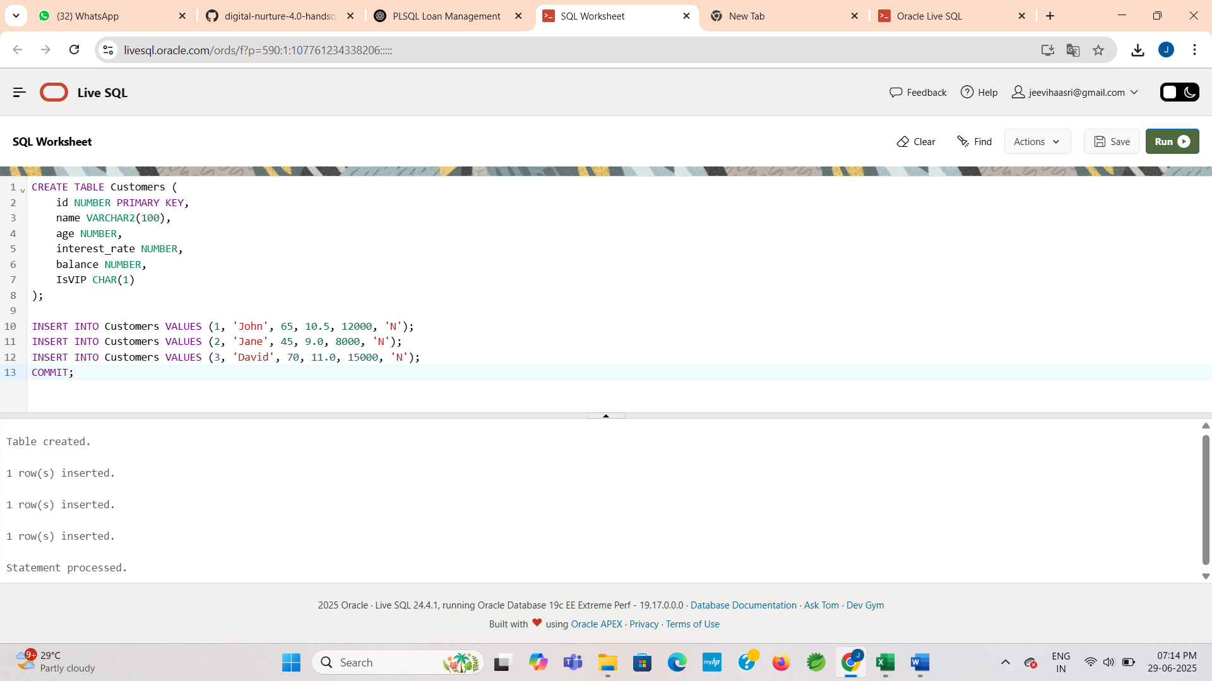

**OUTPUT:**



**Scenario 1: Senior Citizen Loan Discount**

* Apply a 1% discount to interest rates for customers aged above 60.

**CODE:**

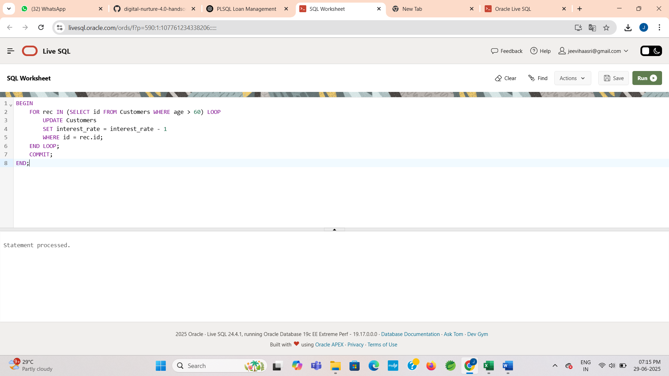

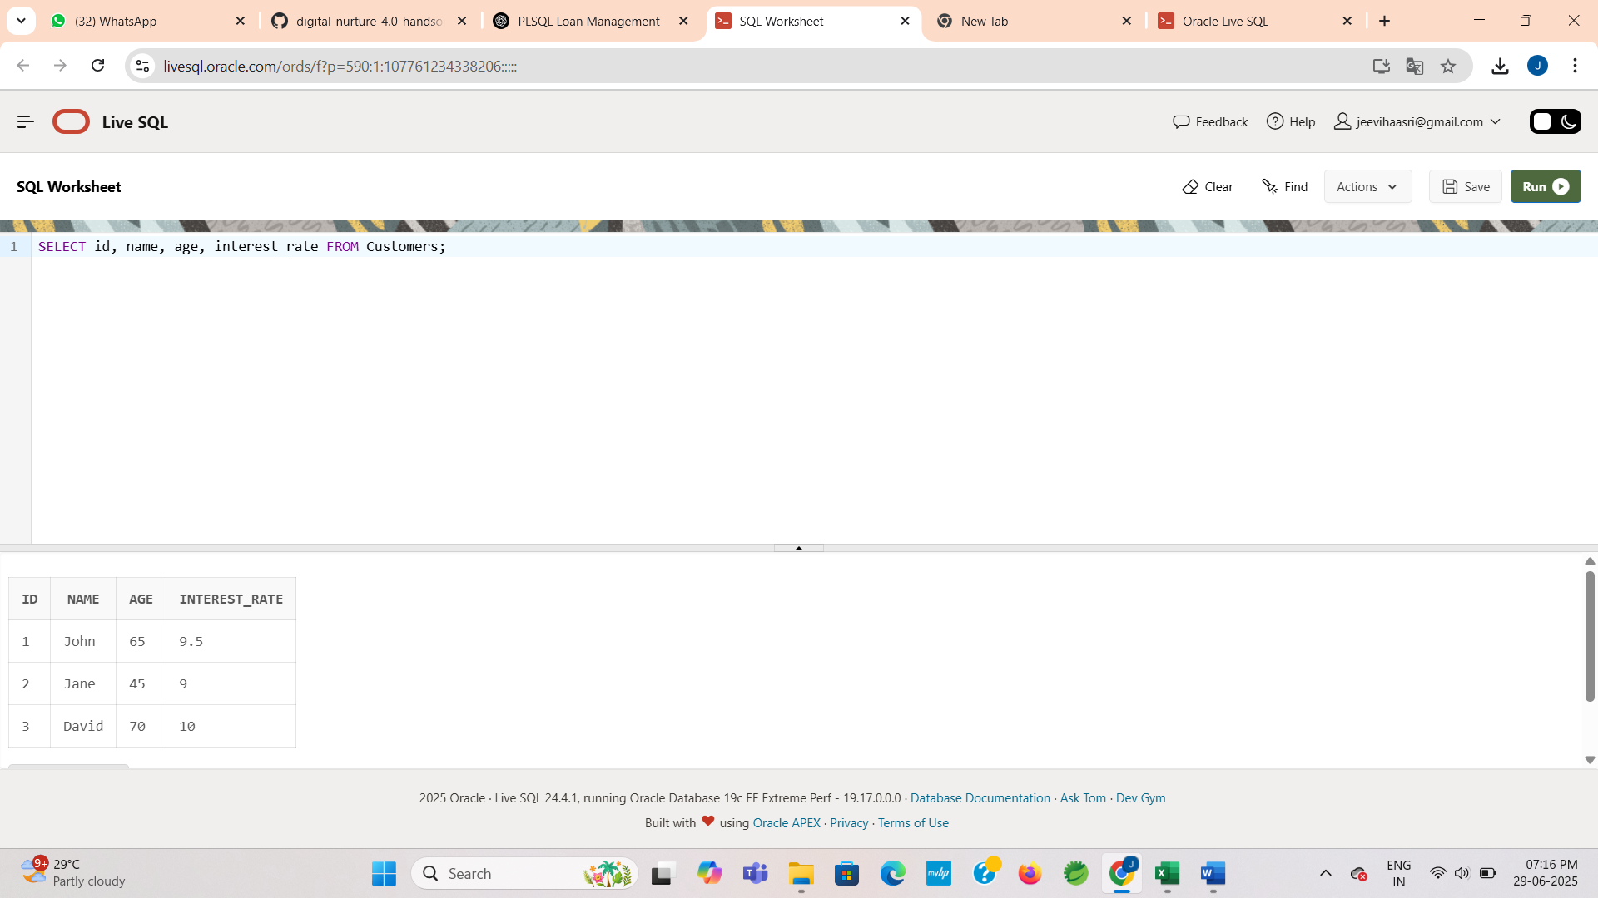

**OUTPUT:**



**Scenario 2: VIP Status Based on Balance**

* Set IsVIP = 'Y' for customers whose balance is over $10,000.

**CODE:**

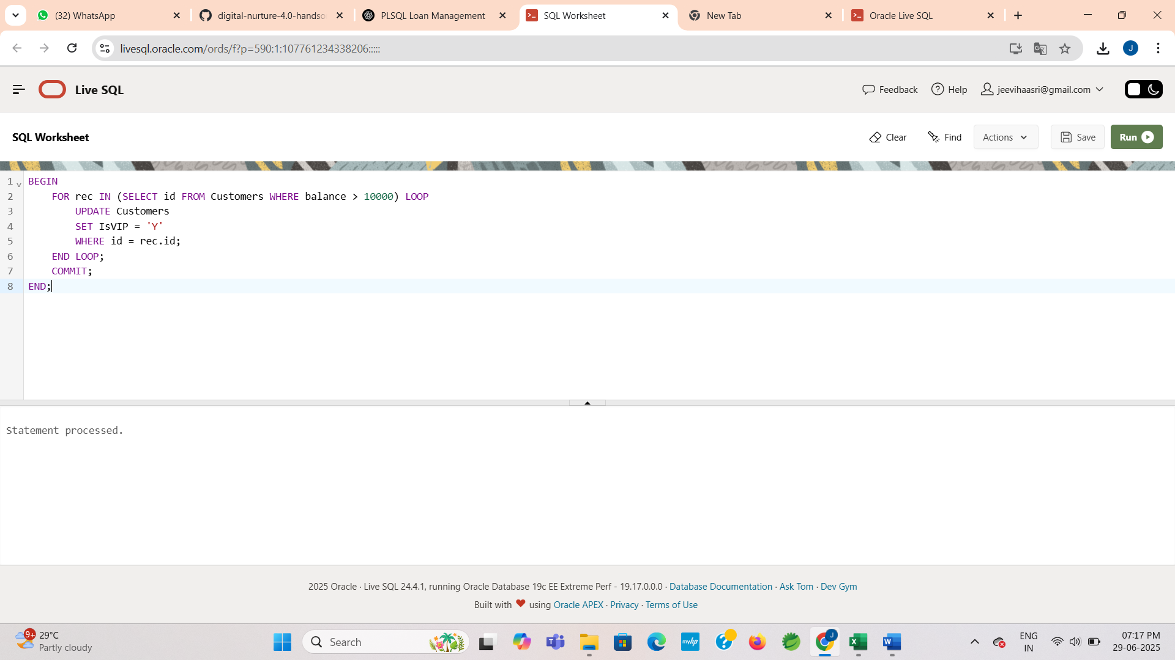

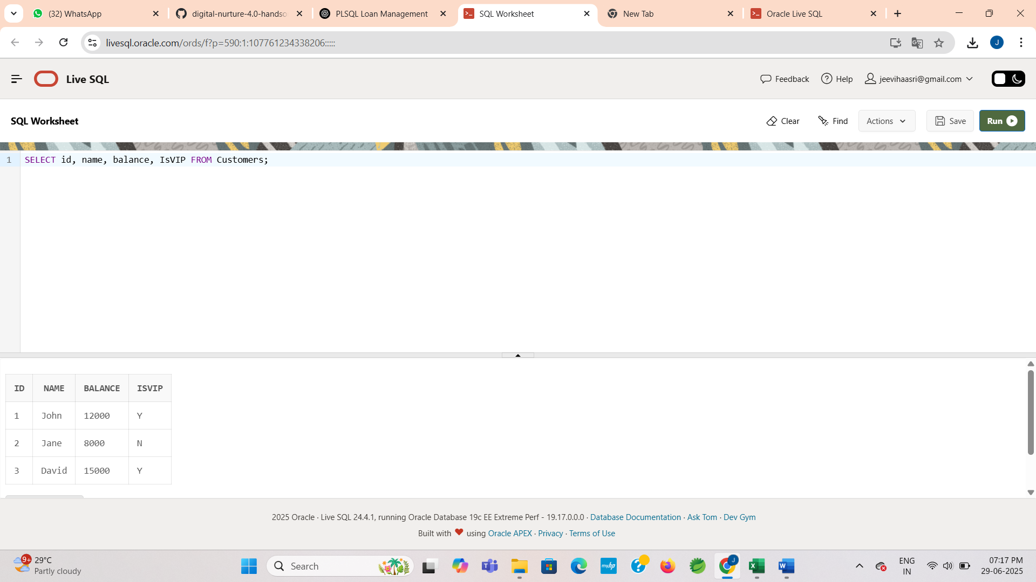

**OUTPUT:**



**Scenario 3: Loan Reminders for Upcoming Due Dates**

**Create table and insert the data:**

**CODE:**

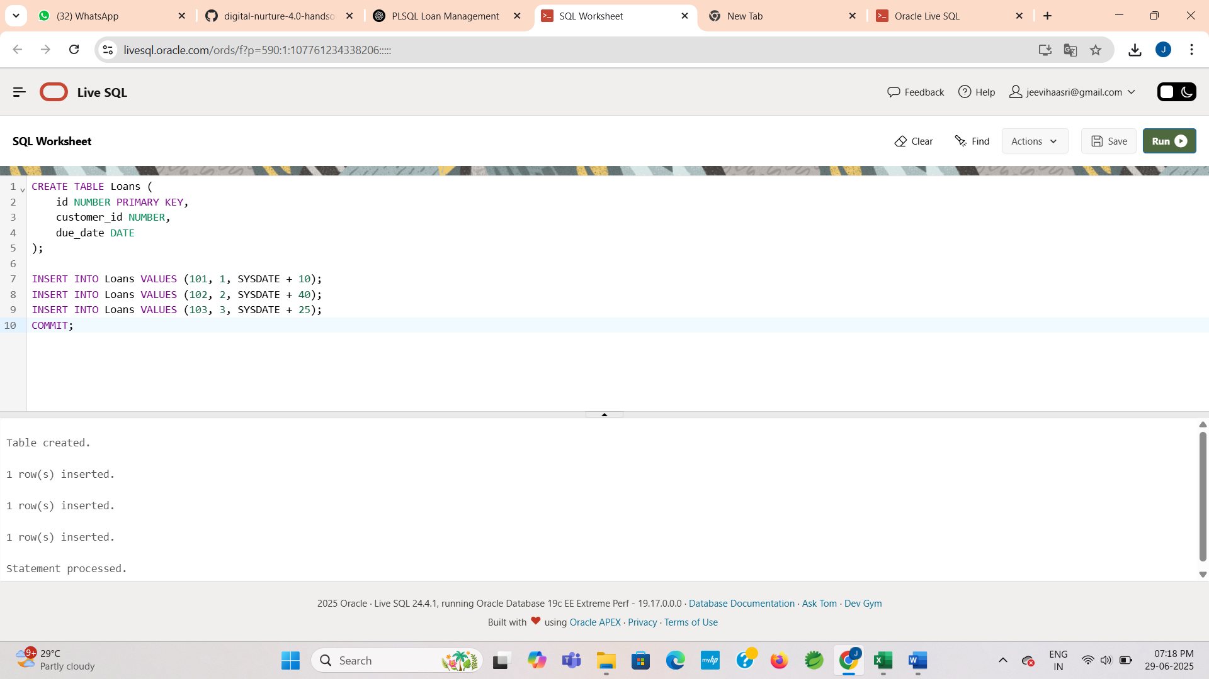

**OUTPUT:**



**Send reminders for loans due within the next 30 days:**

**CODE:**

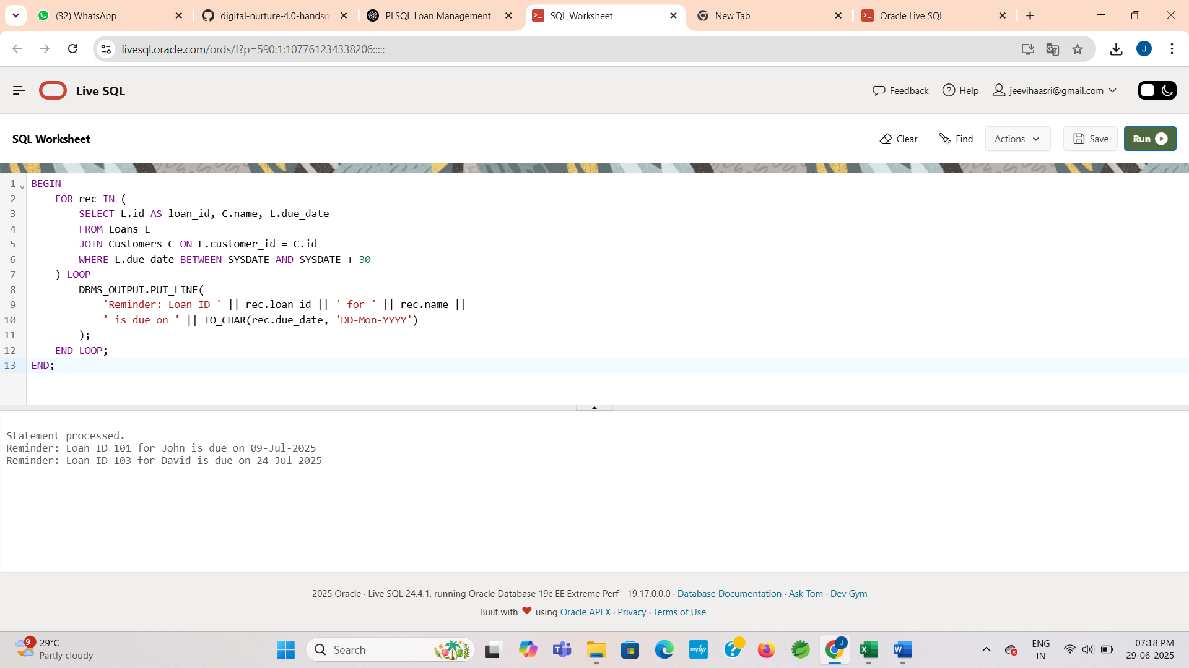

**OUTPUT:**



**Exercise 3: Stored Procedures**

**Scenario 1: Monthly Interest for Savings Accounts**

* The bank needs to process monthly interest for all savings accounts. Apply 1% interest to each balance.

**Step 1: Create table and insert the data**

**CODE:**

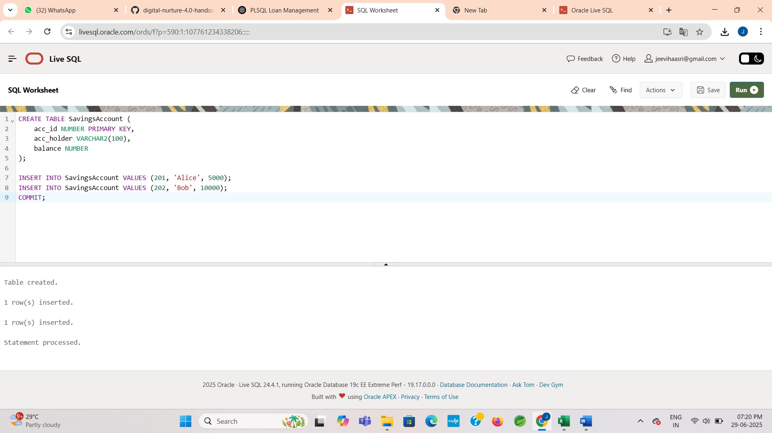

**OUTPUT:**



**Step 2: Create the Procedure**

**CODE:**

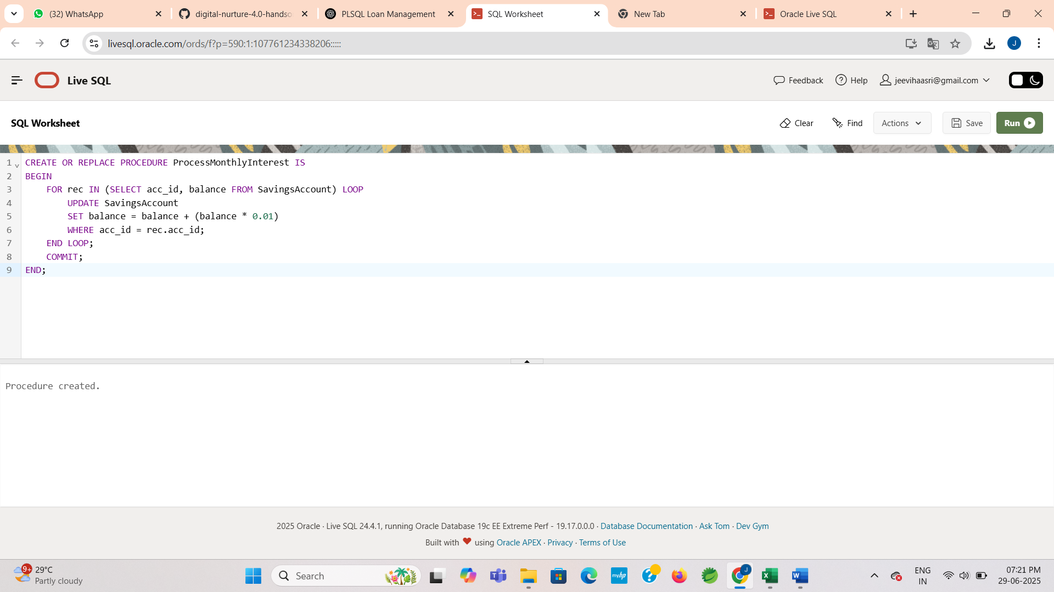

**OUTPUT:**



**Step 3: Execute the procedure**

**CODE:**

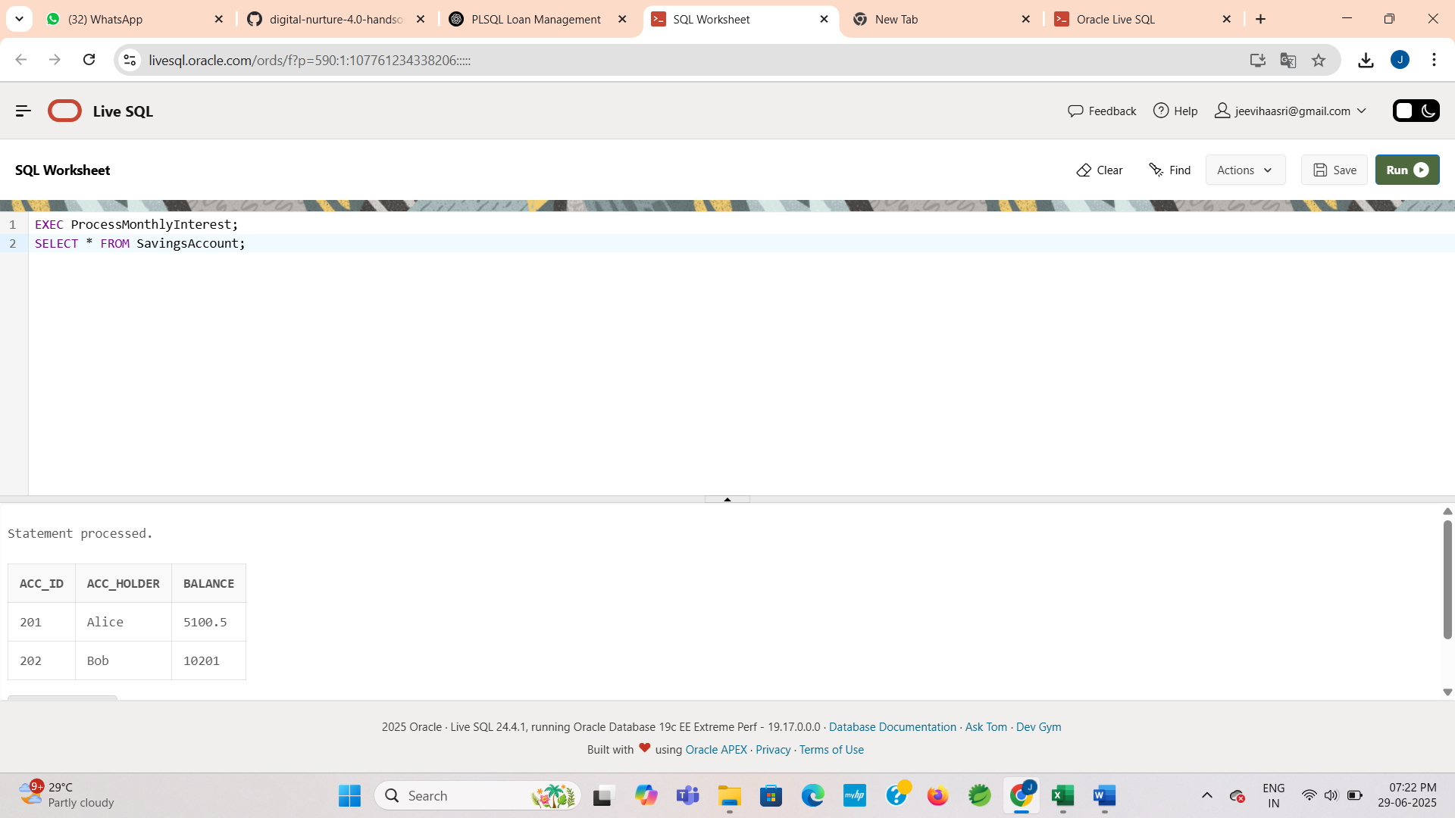

**OUTPUT:**



**Scenario 2: Bonus Scheme for Employees**

* Add a bonus to all employees in a selected department. Bonus percentage is passed as a parameter.

**Step 1: Create table and insert the data**

**CODE:**

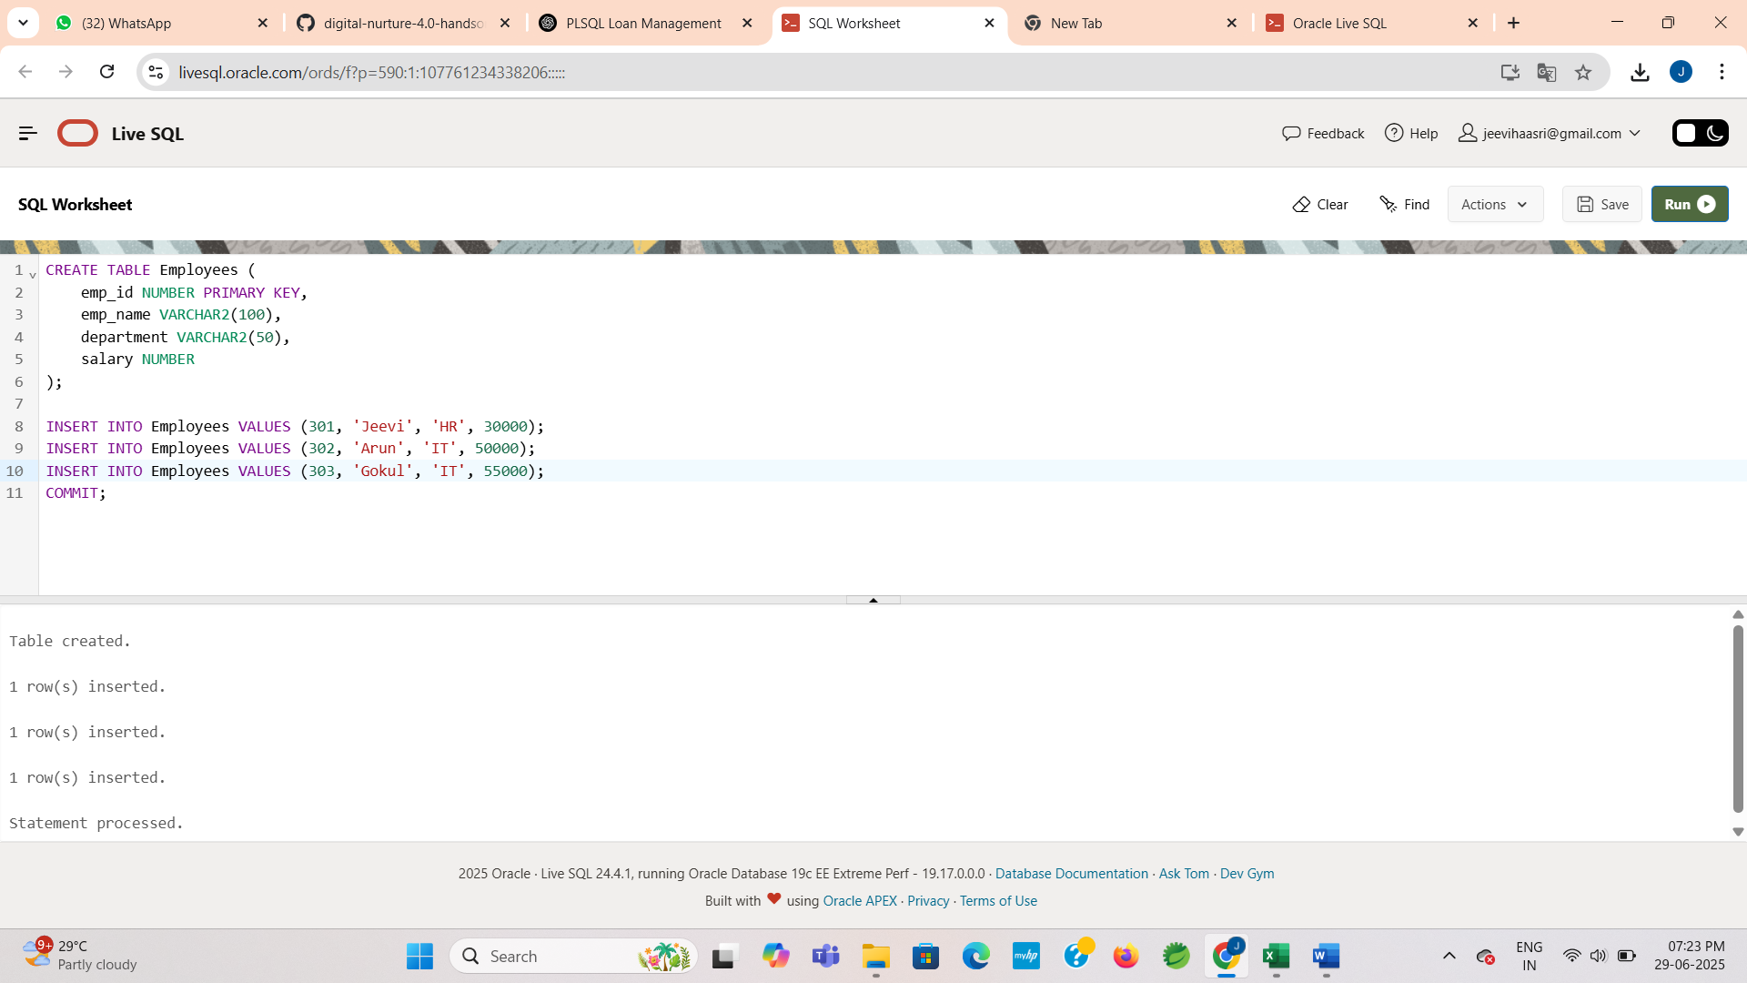

**OUTPUT:**



**Step 2: Create the procedure**

**CODE:**

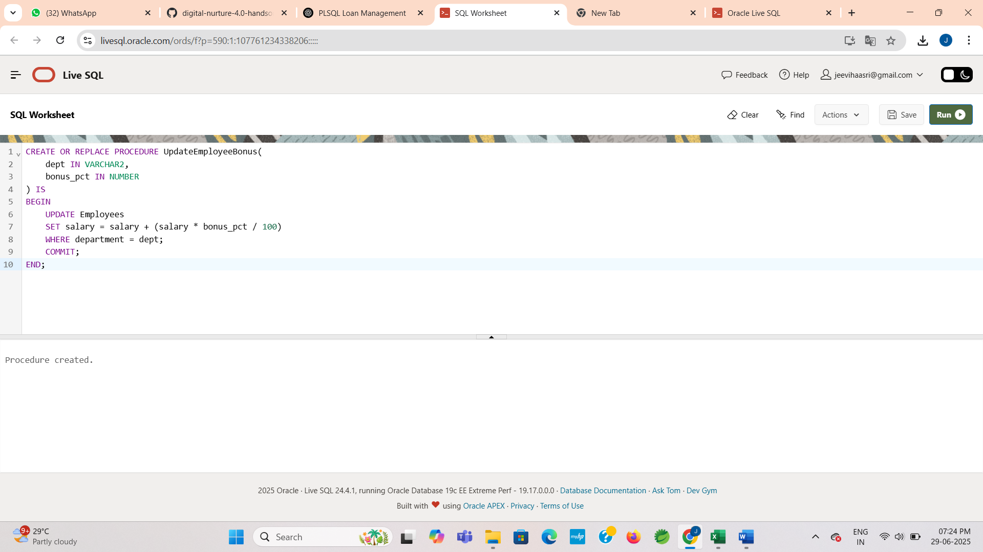

**OUTPUT:**



**Step 3: Execute the procedure**

**CODE:**

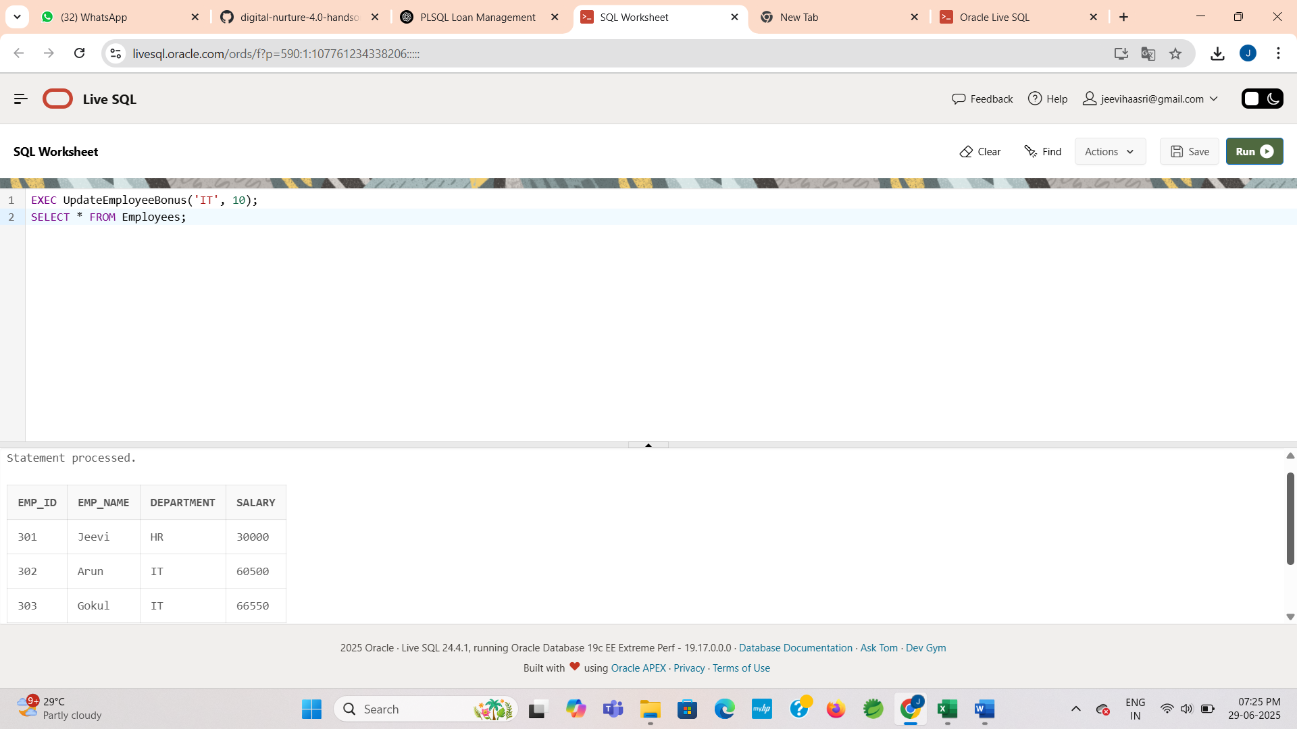

**OUTPUT:**



**Scenario 3: Transfer Funds Between Accounts**

* Allow customers to transfer funds between accounts after checking for sufficient balance

**Step 1: Create table and insert the data**

**CODE:**

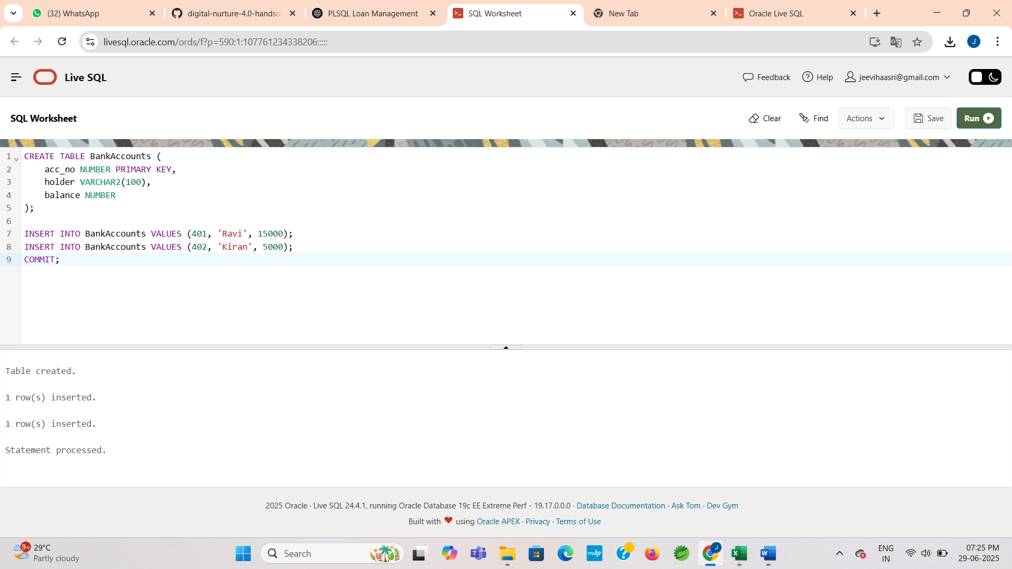

**OUTPUT:**



**Step 2: Create the procedure**

**CODE:**

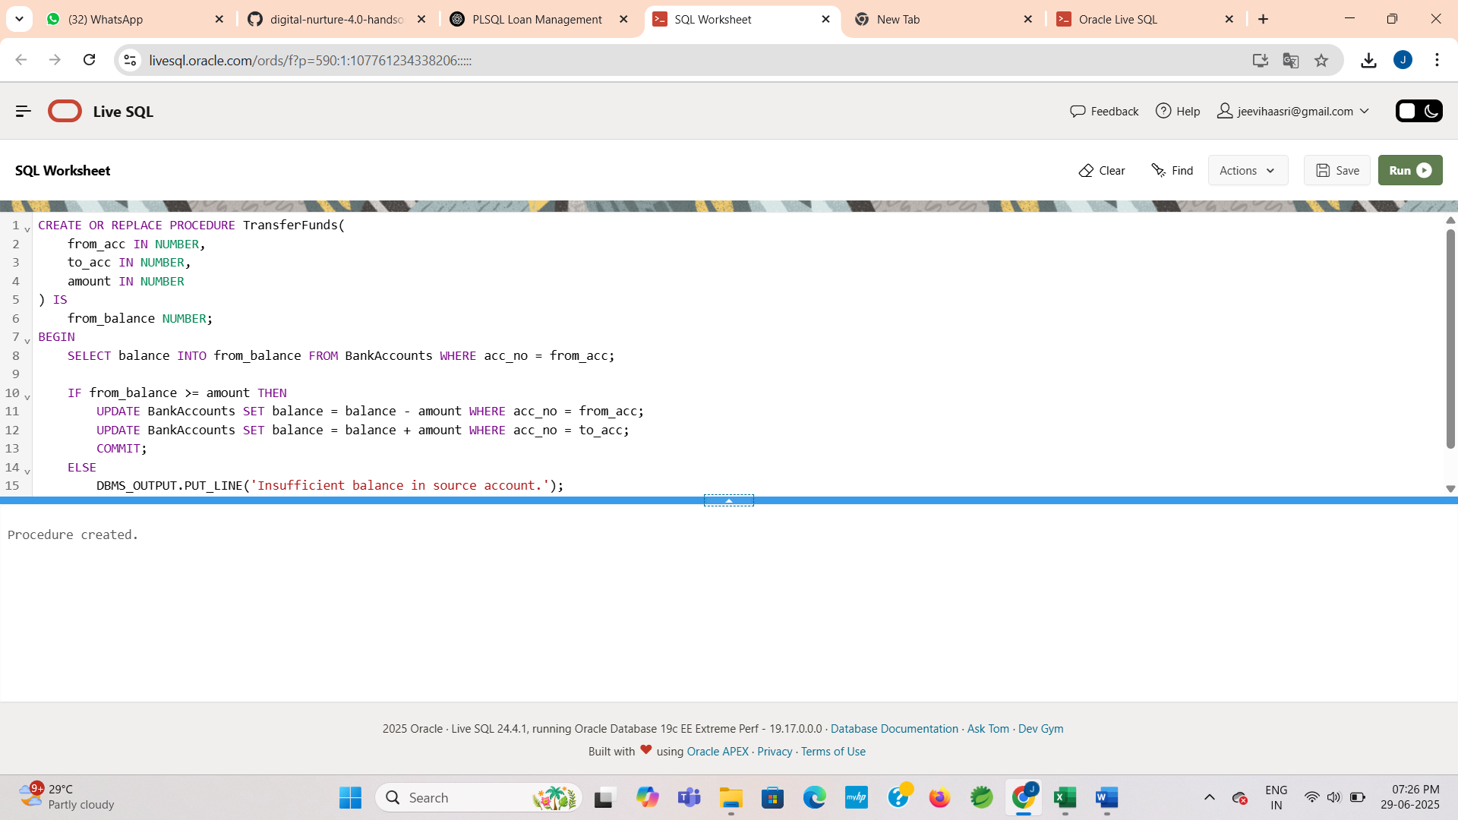

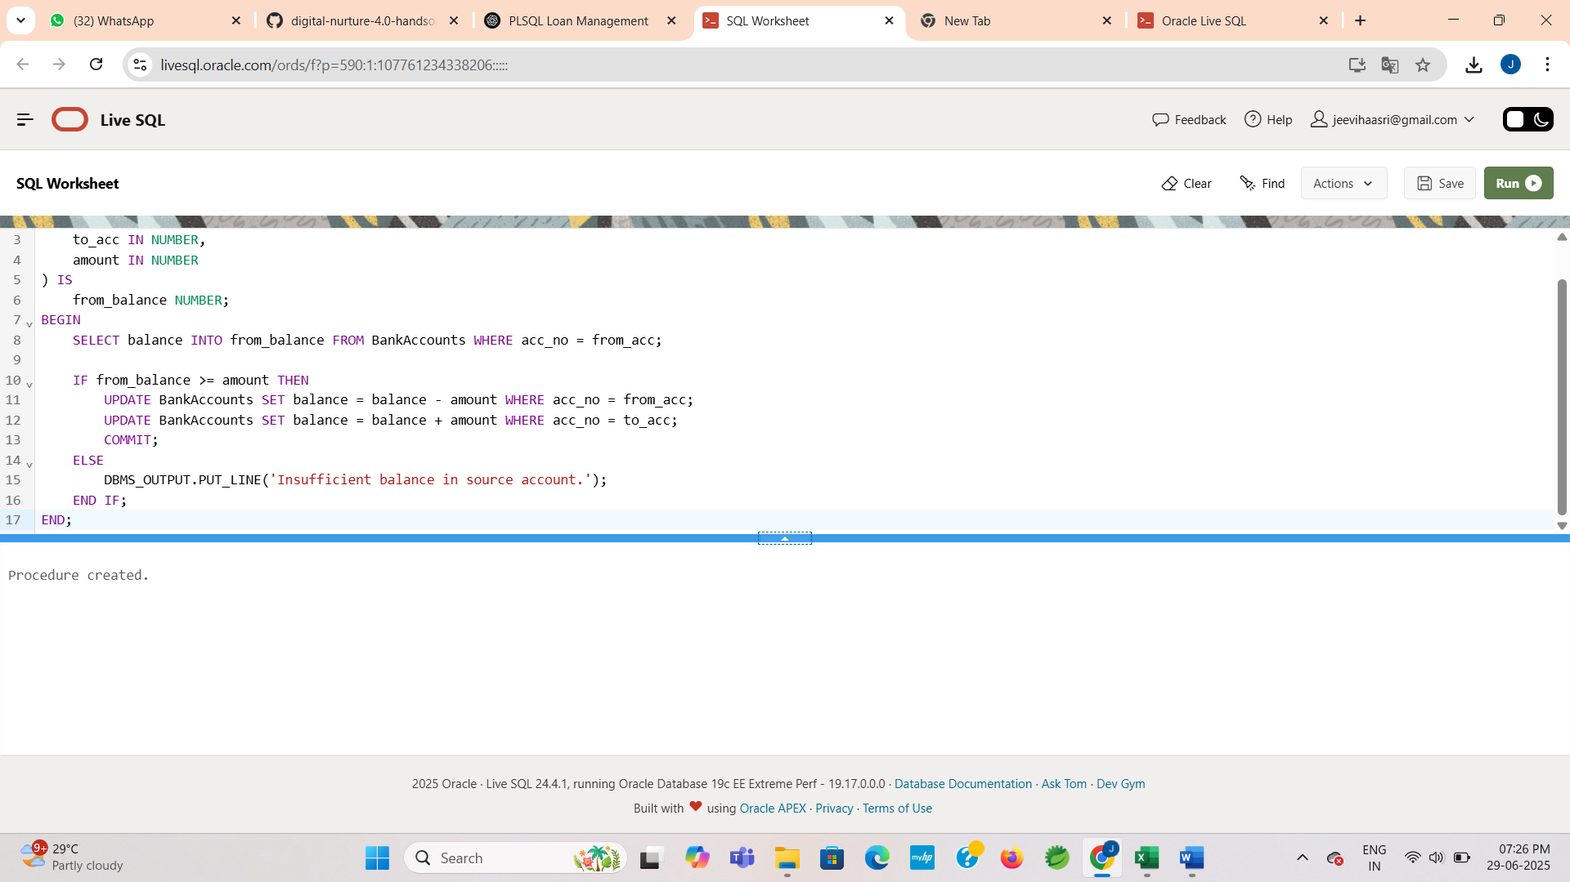

**OUTPUT:**



**Step 3 : Execute the procedure**

**CODE:**

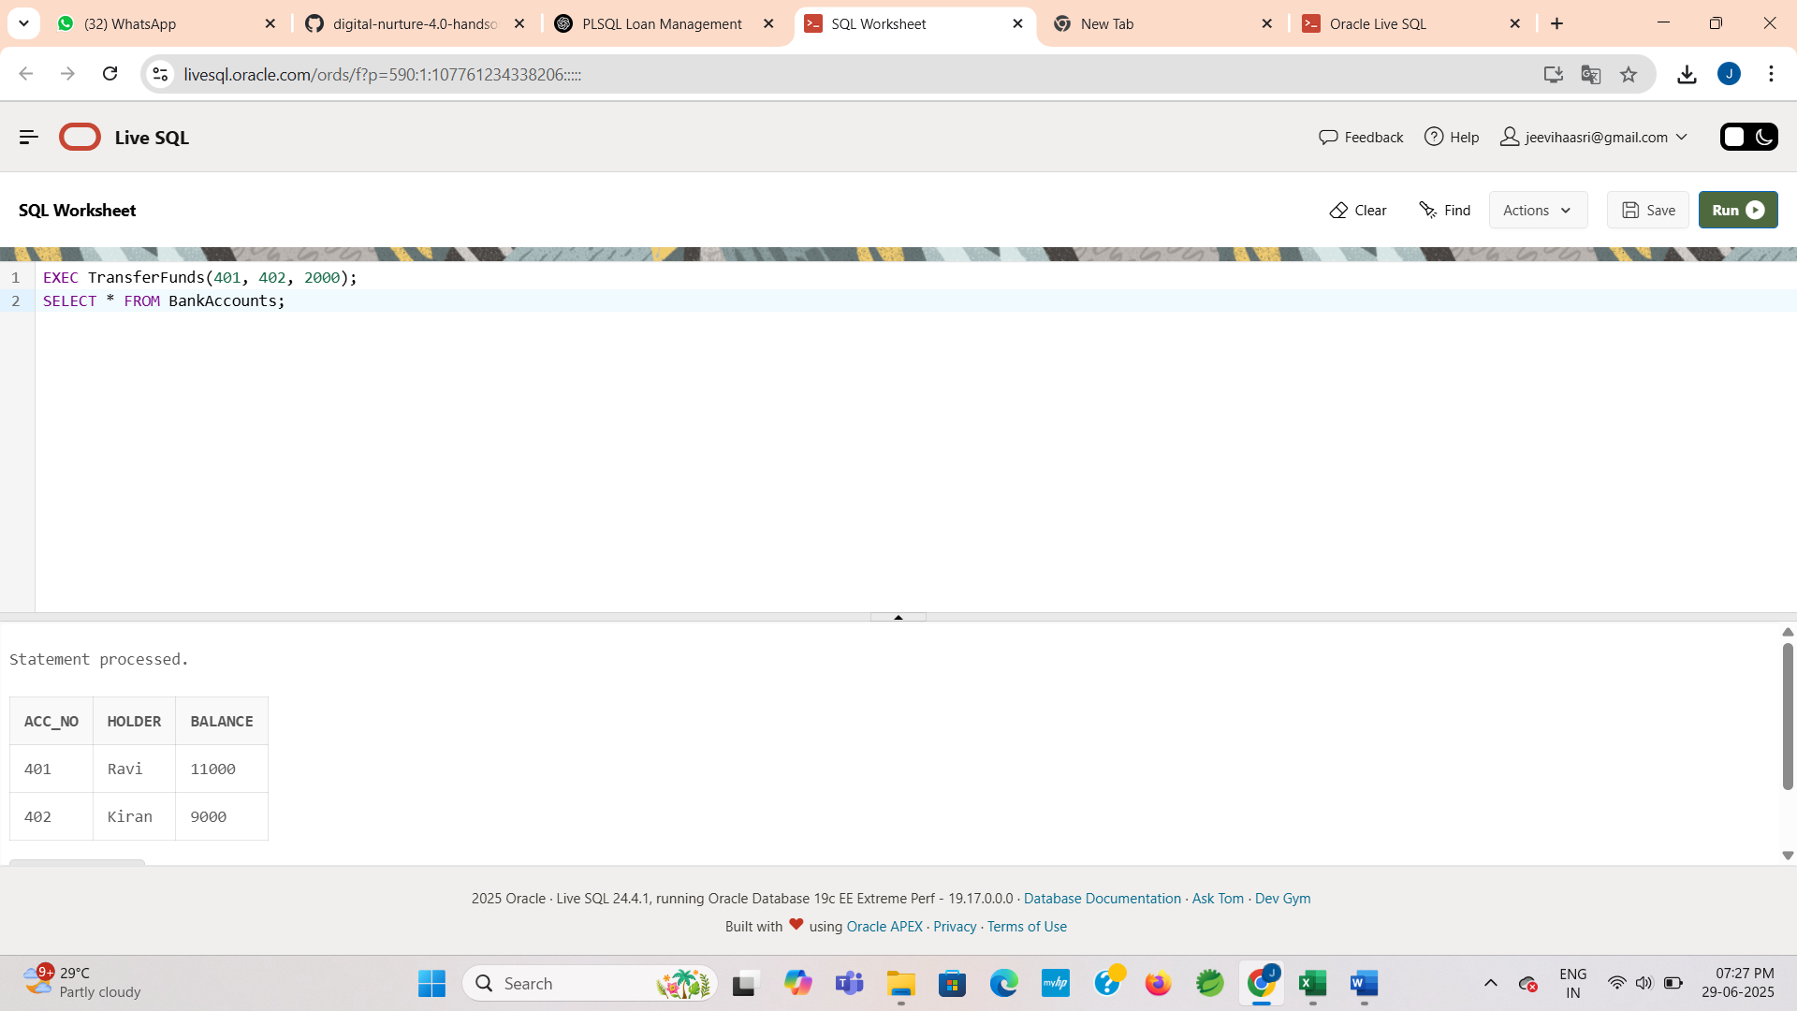

**OUTPUT:**

